Technical Specification

WRICEF ID.: | BAPI
Project Name: | Support Project
Client Name: | EVER ENVIRO
WRICEF Description: | BAPI (For Sales Order Creation)

TECHNICAL SPECIFICATION

Section 1: General Information
Project: | Support Project | Functional Area: | SD
VSD Functional Consultant | Harish Giri and Rohit Mahaveer | VSD Developer | Shivani Jha
Object Name: | ZSD_SO_MASS_UPD
Object Id | BAPI
Description | Create Sales Order for one time customer and regular customer
Development Class |  |  |  | Package
Package | ZSD
File Name & Location in Solution Manager for FSD
File Name & Location in Solution Manager for TSD
Menu Path: (if applicable)
Mode | Foreground Background
Frequency | Monthly Weekly Daily Adhoc Others
Title:
Application Key: | NA
Complexity: | High Medium Low

Table of Contents
1 Scope Summary 5
1.1 Development Objects per System 5
2 Business Details 6
2.1 Summary / Business Background 6
2.2 Assumptions 6
3 Development Scope 7
3.1.1 Detailed Process Description 7
3.1.2 Data Model 7
3.2 Web Service - NA 7
3.2.1 Configuration 7
3.2.2 Development Objects 7
3.2.3 Business Logic 7
3.2.4 Error Handling 7
3.3 Workflow Development - NA 8
3.3.1 Configuration 8
3.3.2 Business Object creation / extension 8
3.3.3 Triggering Mechanism 8
3.3.4 Creation/Change of Workflow 8
3.3.5 Workflow Business Logic 8
3.3.6 Error Handling 8
3.4 Reports 8
3.4.1 Selection Screen 8
3.4.2 Business Logic 8
3.4.3 Output Format 8
3.4.4 Run Mode 8
3.4.5 Error Handling 8
3.5 Forms - NA 9
3.5.1 Layout Details / Sample Formats 9
3.5.2 Business Logic for Data Retrieval 9
3.5.3 Triggering Mechanism 9
3.5.4 Special Considerations 9
3.5.5 Error Handling 9
3.6 Dialog program / Web Developments (PCUI - BSP / WebDynpro) - NA 9
3.6.1 General 9
3.6.2 Screen Sequence 9
3.6.3 Business Logic 9
3.6.4 Bespoke Tables Updated 9
3.6.5 Error Handling 9
3.6.6 Multi-User Access Consideration 9
3.6.7 Branding Requirements 9
3.6.8 Screen layout 9
3.6.9 Field Definition 9
3.6.10 Menu implementation 9
3.6.11 Database update processing 10
3.7 Enhancements - 10
3.7.1 List of Enhancements 10
3.7.2 Business Logic 10
3.8 SAP PI – ABAP Proxy Development - NA 10
3.9 Class / Interface Development - NA 10
3.10 IDOC Development - NA 11
3.10.1 General 11
3.10.2 IDoc Customizing 11
3.10.3 Record Layout 11
3.10.4 Extension 11
3.10.5 IDoc Type 11
3.10.6 Message Type 11
3.10.7 Logical System 12
3.10.8 Process Code 12
3.10.9 Distribution Model 12
3.10.10 Transactional RFC Port 12
3.10.11 File Port 12
3.10.12 XML File port 12
3.10.13 XML HTTP 12
3.10.14 Partner profile 13
3.10.15 Inbound/outbound Parameters 13
3.10.16 Message Control 13
3.10.17 IDoc Processing 13
3.10.18 ABAP Processing 13
3.10.19 Description of Output 13
3.10.20 Programs/function modules for creation of IDOCs 14
3.10.21 Error handling for inbound/outbound (link to any workflow developments) 14
3.10.22 FTP scripting requirements 14
3.11 Function Module / RFC / BAPI - NA 14
3.12 Data Dictionary Objects - NA 16
3.12.1 Bespoke Table 16
3.12.2 Search helps 17
3.12.3 Lock Objects 17
3.13 Actions - NA 17
4 Authorizations 18
5 Message Class and Messages 19
6 Archiving – NA 20
7 Unit Test 21
7.1 Unit Test Specification 21
7.2 Test Data or Sample file 21
8 Version Control 22
9 Glossary - NA 23

Scope Summary

Development Objects per System

S.No | System | Package | Development  Object | Description
 | S4HANA | ZSD | ZSD_SO_MASS_UPD | Create Sales Order for one time customer

Business Details

Summary / Business Background

Title | Sales Order Creation
Description | Create Sales Order for one time customer and regular customer
Business purpose | Create Sales Order for one time customer and regular customer
Application area | SD
Tcode | ZSD_SOMASS

Function Module BAPI -

Function Module Name | BAPI_SALESORDER_CREATEFROMDAT2
Function Module Text | Sales Order: Create Sales Order
Type of Function Module | Remote-Enabled
Function Group | 2032
Business Object | BUS2032

Business Logic | Two type of excel sheets are use in this pgm.  First excel sheet contain one time customer details and create sales order.  Second excel sheet contain regular customer details and create sales order.  As per the excel sheet data pass data into BAPI parameter and get salesdocument number as out put.
Error Handling | Before run BAPI, excel sheet validations are there  1.Excel should be .xls or .xlsx formate other wise pgm throw error message.  2.If same name excel already uploaded pgm throw error message.  3.Order type column in excel should be 'ZFOM' or 'ZLFO' other wise pgm throw error message.  4. If upload blank excel then pgm throw error.  After run BAPI.  5. In excel Aadhar no. ,PAN no. are maintained, pgm also validate these values.  like Aadhar no. and PAN no. length should be 12 and 10 respectively other wise  pgm throw error.  Aadhar no. should have only digit and PAN no. should have alphanumeric other  Wise pgm throw error.  For error handling got return table in BAPI. As per the return table output show result in ALV of BAPI program ZSO_SD_MASS_UPLOAD and tcode is ZSO_MASS.

Unit Test

Unit Test Specification
After upload one time customer excel sheet or regular cutomer excel sheet (below I attached for referance) in BAPI pgm
output show in ALV report.
When click on sales order column it will display VA03
transaction against particular sales order.

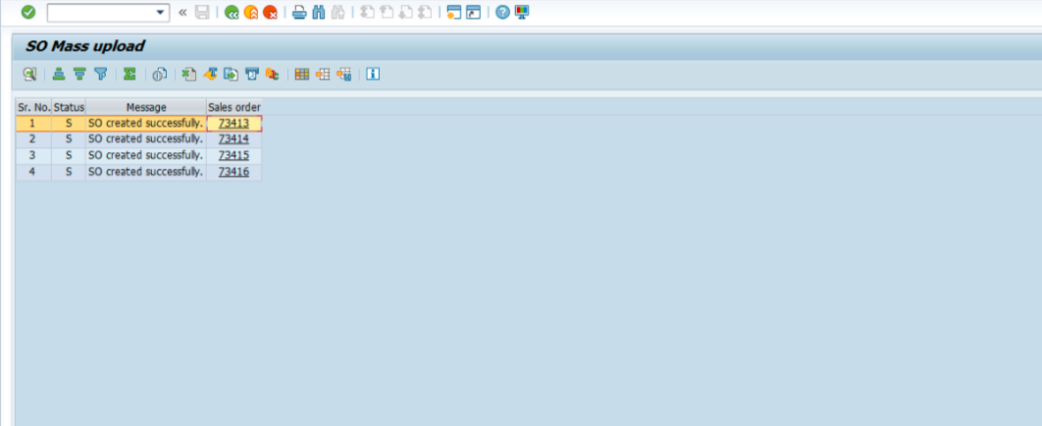

Test Data or Sample file
here is a referance of excel sheet for one time customer.
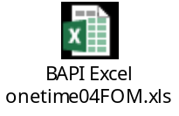
here is a referance of excel sheet for regular customer.
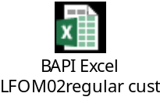

Version Control
Version | Date | Comment/Changes | Completed By | Transport
807 | 10.03.2025 | VSD: driver pgm - one time customer (SO) on 10.03.25 | Shivani Jha | DS4K903606

